

# The Cloud Hosting Landscape

Before jumping into specifics ,let's get the big picture. Cloud

hosting isn't just one thing -it's a spectrum of services that give you different levels of control and responsibility.



Infrastructure as a Service (IaaS)

You rent virtual machines and manage everything else

Platform as a Service (PaaS)

You deploy apps on a managed platform

Software as a Service (SaaS)

You just use the software - everything's handled

# Infrastructure as a Service (IaaS)

IaaS is the foundation layer - you're essentially renting

virtual computersinsomeone else's datacenter. You get raw computing power, storage, and networking, but you're responsible for everything else.

## What You Get What You Manage

Virtual machines

Storage space Network infrastructure Basic security features

Operating system Applications

Runtime environments Data and configurations



**Popular Examples:** Amazon EC2, Google Compute Engine, Microsoft Azure VMs, DigitalOcean Droplets.

# Platform as a Service (PaaS)

PaaS sits in the sweet spot - you get a ready-to-use platform for deploying applications without worrying a bout the underlying infrastructure. It's like having a fully equipped kitchen where you just need to bring your ingredients.



The Platform Handles Operating system management Runtime environments

Auto-scaling Load balancing

Security patches

YouFocusOn

Writing application code Database design Business logic

User experience

Application configuration

**Popular Examples:** Heroku, Google App Engine, AWS Elastic Beanstalk, Vercel, Netlify

# Software as a Service (SaaS)

SaaS is the "just use it" model. The software is fully built, hosted, and maintained by the provider.You access it through a web browser or mobile app, and that's it.

## Communication Tools

Gmail, Slack, Microsoft 365 - ready-to-use communication platforms with no setup required.

## Business Applications

Salesforce, HubSpot, QuickBooks - complete business solutions that you can use immediately.

## Creative Suites

Adobe Creative Cloud, Canva, Figma - professional tools accessible from any device with internet.

# Real-World Decision Matrix

## Choose IaaS When

You need custom OS configurations Compliance requires specific security controls You're migrating legacy applications

You have dedicated DevOps expertise

## Choose PaaS When

You want to focus on application development You need rapid prototyping and deployment Your team lacks infrastructure expertise You're building web or mobile apps

## Choose SaaS When

You need standard business functionality You want zero maintenance overhead You need quick deployment for end users

Budget is tight and predictable costs matter

# Cloud Service Models Overview

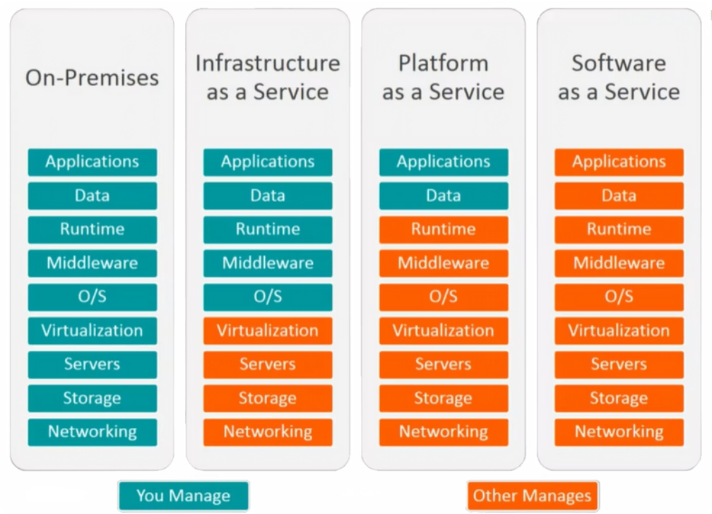

Cloud vs On-Premises Hosting:

These are my personal study notes comparing cloud and on-premises hosting solutions. This comparison covers everything from basic definitions to real-world implementation considerations.

I've structured these notes to help you quickly understand the key differences, benefits, drawbacks, and decision factors for both approaches.

Costs

Predictable Costs

High Upfront Costs

Requires Skilled Staff

Control

On-Pre mises Hosting

Complexity

# What is Cloud Hosting?

## Basic Definition

Cloud hosting means your applications and data live on servers owned and managed by third-party providers like AWS, Azure, or Google Cloud. Think of it as **renting** computing resources instead of buying them.

The "cloud" is really just someone else's data center, but with key advantages: scalability, reliability, and professional management. You access everything over the internet.

## Key Characteristics Popular Providers Service Models

Pay-as-you-use pricing Instant scalability Geographic distribution Managed infrastructure

Amazon WebServices (AWS)

Microsoft Azure Google Cloud Platform DigitalOcean

IaaS (Infrastructure) PaaS (Platform) SaaS (Software)

Serverless computing

# What is On-Premises Hosting?

On-premises (often called "on-prem") hosting means you **own and operate** the physical servers, networking equipment , and infrastructure. Everything runs in your organization's facilities - whether that's a dedicated server room, basement, or full data center.





## Physical Infrastructure Direct Management Local Access

You purchase, install, and maintain all hardware including servers, storage devices, networking equipment, and cooling systems. This means upfront capital investment but complete ownership.

Your IT team handles everything: hardware maintenance, software updates, security patches, backups, and troubleshooting.

You have full control but also full responsibility.

Servers are physically located in your building or facility. This means potentially faster local access but also means you're responsible for physical security, power, and environmental controls.

# Cloud Hosting: The Good, Bad, and Reality

## The Advantages (Why Everyone's Moving to Cloud)

 **Scalability:** Need more resources? Click a button.Traffic spike? Auto-scaling handles it.

 **Cost Efficiency:** No upfront hardware costs. Pay only for what you use.

**Reliability:** Built-in redundancy across multiple data centers.

**Maintenance-Free:** Provider handles updates, security patches, hardware failures.

 **GlobalReach:**Deploy applications worldwide in minutes.

## The Drawbacks (What They Don't Always Tell You)

 **Ongoing Costs:**Monthly bills can add up overtime.

 **Internet Dependency:** No connection = no access to your systems.

 **Less Control:** Limited customization options.

 **Vendor Lock-in:** Switching providers can be complex and expensive.



# Performance and Reliability Comparison



## Cloud Performance

**Network latency:** Internet speed affects response times

**Shared resources:** Performance can vary based on other tenants

**Geographic distribution:** Can reduce latency for global users

**Auto-scaling:** Handles traffic spikes automatically

## Performance Factors

Performance isn't just about raw computing power. It's about **latency, availability, and consistency**. Here's what affects performance in each model:

## On-Prem Performance

**Local access:**Faster for users on the same network

**Dedicated resources:** Consistent performance, no sharing

**Custom optimization:** Can tune for specific applications

**Limited scalability:** Hard to handle unexpected traffic

# Security Considerations

Security is often the biggest concern when choosing between cloud and on-prem. Both have unique advantages and risks . Let me break down the reality of each approach:

## Cloud Security On-Prem Security

### Pros:

Professional security teams 24/7 Automatic security updates

Built-in DDoS protection

Compliance certifications (SOC 2, ISO 27001)

### Cons:

Shared responsibility model complexity Less control over security policies

Potential for data breaches at provider level

### Pros:

Complete control over security measures Data never leaves your premises

Custom security implementations Easier compliance for some regulations

### Cons:

Requires dedicated security expertise Physical security responsibilities Manual patch management

Higher risk of human error